**GIT-2 Task**

1. **Install git.**

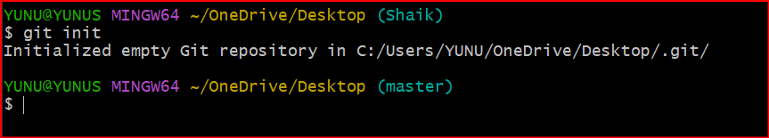

1. **Create a repo in github with README.md and .ignore file.**

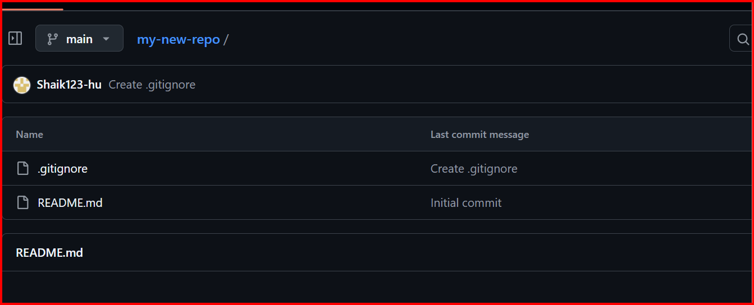

**3.** **Clone the created repo to local.**

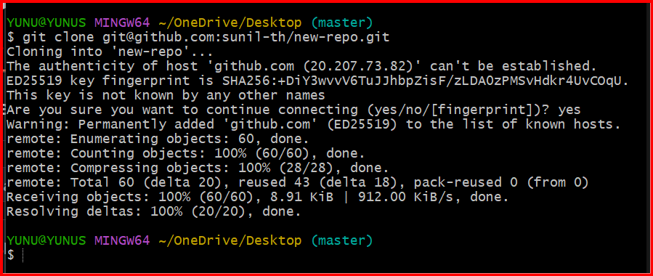

**4.Create two files in local repo.**

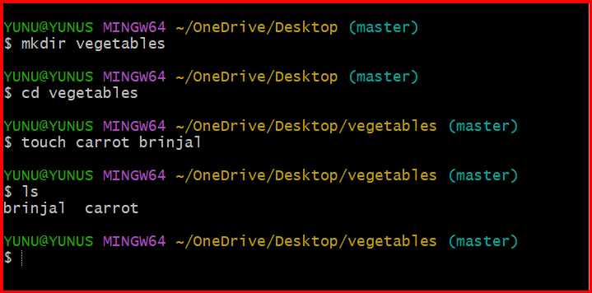

**5.** **Commit two files and push to central Repository.**

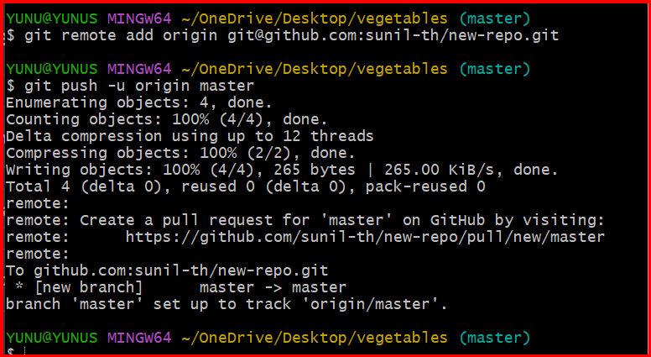

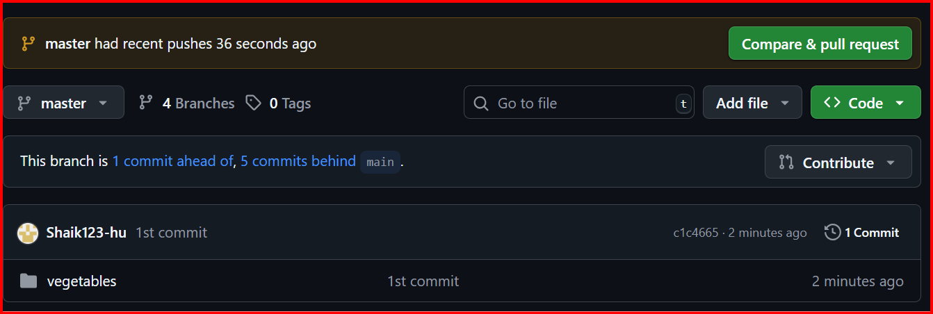

**6.** **Create a branch in local and create a sample file and push to central.**

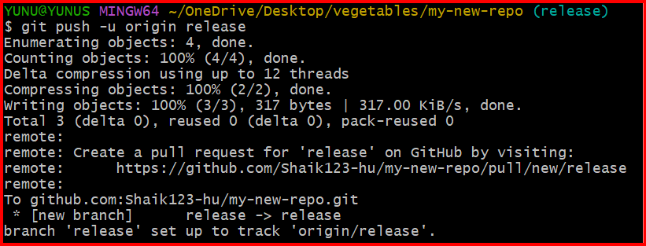

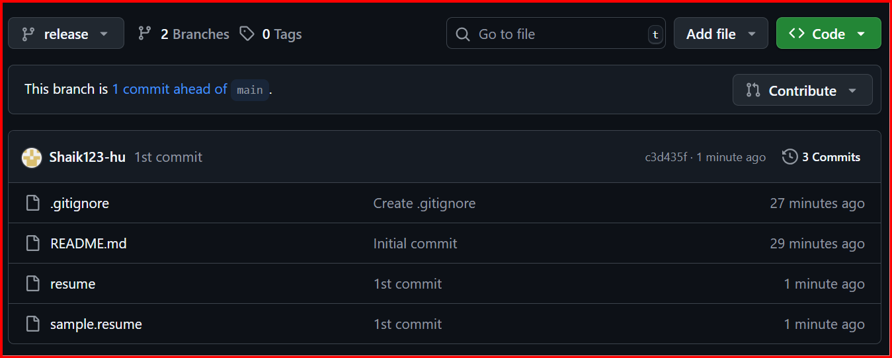

**7.** **Create a branch in github and clone that to local.**

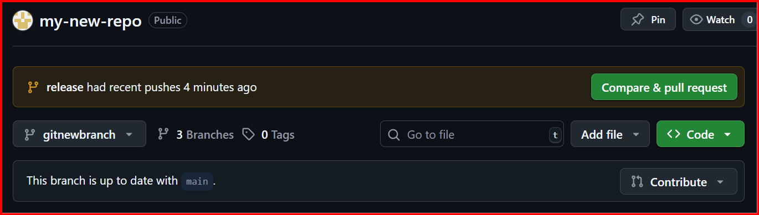

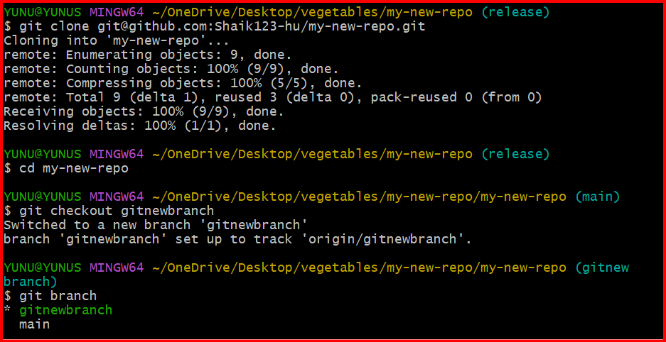

**8.** **Merge the created branch with master in git local.**

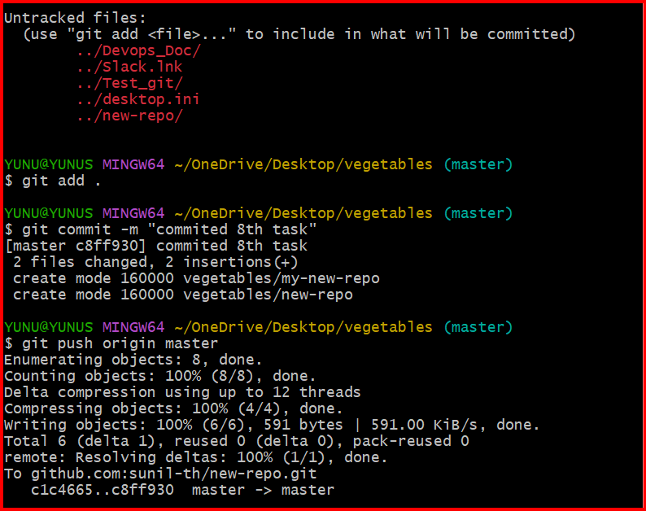

**9.** **Merge the created branch with master in github by sending a pull request.**

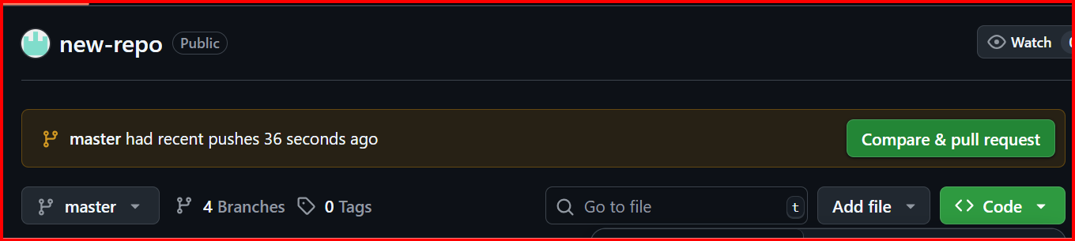

**10.** **create a file in local and send that to branch in github.**

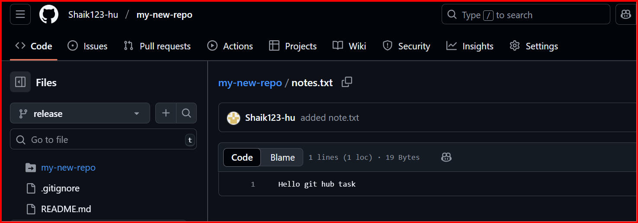

**11.** **clone only a branch from github to local.**



**12.** **create a file with all passwords and make that untrackable with git.**

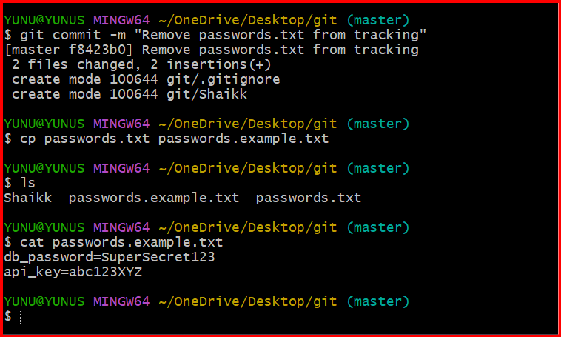

**13.** **make a commit and make that commit reset without savings changes.**

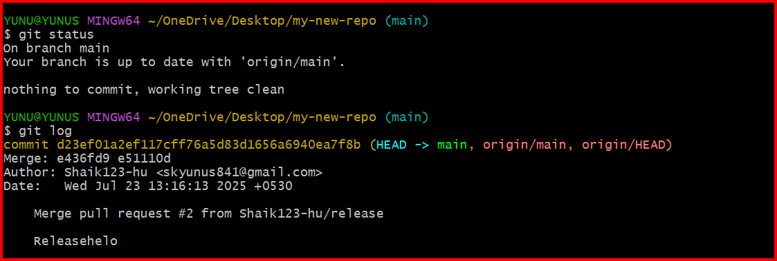

**14.** **Revert a commited commit to the older version.**

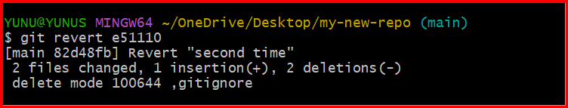

**15.** **push a file to stash without savings the changes and work on another file.**

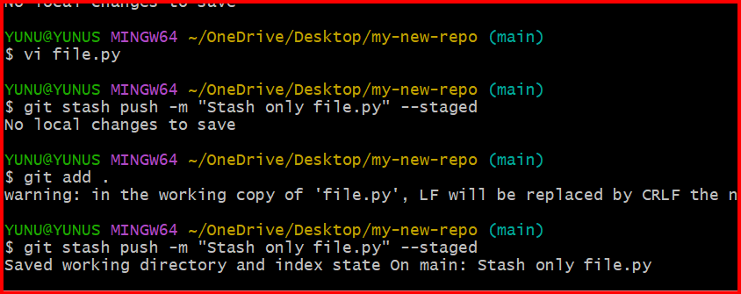

**16.** **undo the stash file and start working on that again.**

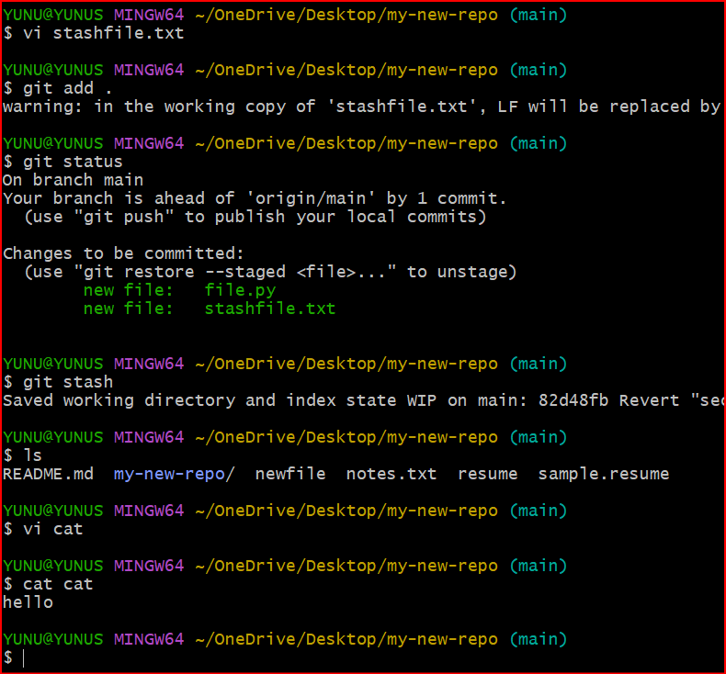

**17.** **generate a ssh-keygen and configure into github.**

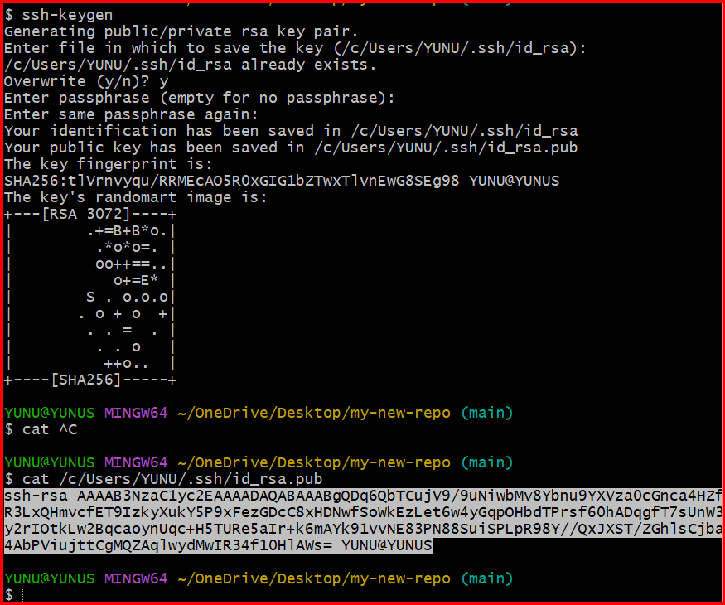

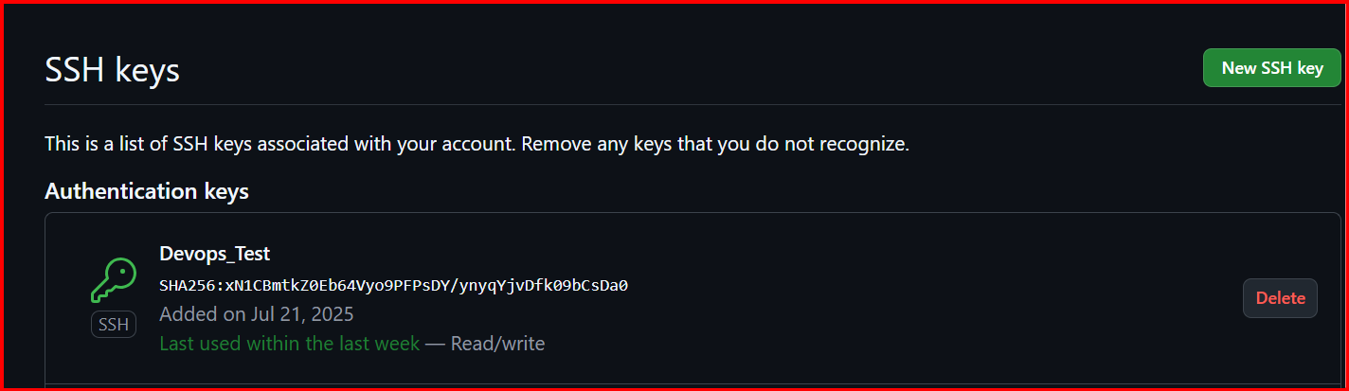

**18.** **configure webhooks to github.**



19. basic understanding of .git file.

* The .git folder is **created when you run git init** — it makes your project a Git repository.
* It contains **all Git metadata**, including commit history, branches, configs, and the staging area.
* Key components:
  + config – local Git settings
  + HEAD – current branch pointer
  + refs/ – branch and tag references
  + objects/ – actual data (commits, files, trees)
  + index – staging area (what’s ready to be committed)
* **Deleting .git removes all version history** and turns the folder into a normal directory.
* It’s the **core database** Git uses to track your project.

Let me know if you want a visual or to explore any part deeper.

20. Check all the logs of git.

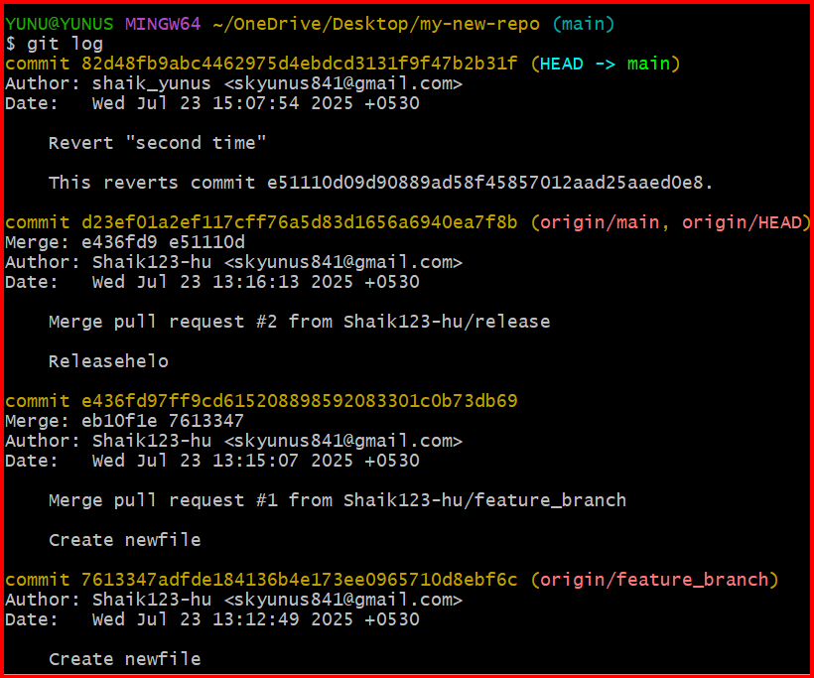

21. Rename the commit message.

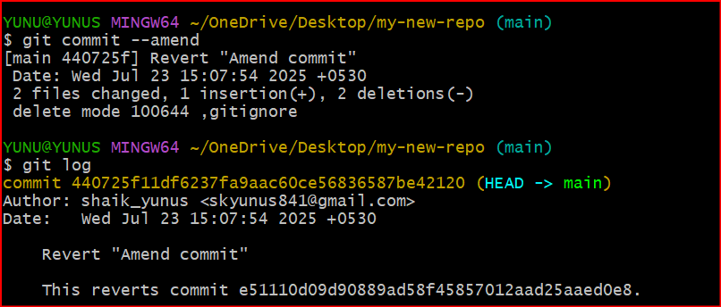

22. Merge multiple commits into single commit.

